1. Overview
Q&A (0)
You’ve created audio for 3D projects, including implementing spatial audio for environmental sounds, dynamic footsteps triggered by animation events, and reverb zones to simulate enclosed spaces.
In this tutorial, you’ll see those concepts applied in a 2D context. You'll explore a 2D version of a similar scene with comparable audio incorporated, and you’ll discover how audio functionality remains similar or differs in a 2D project.
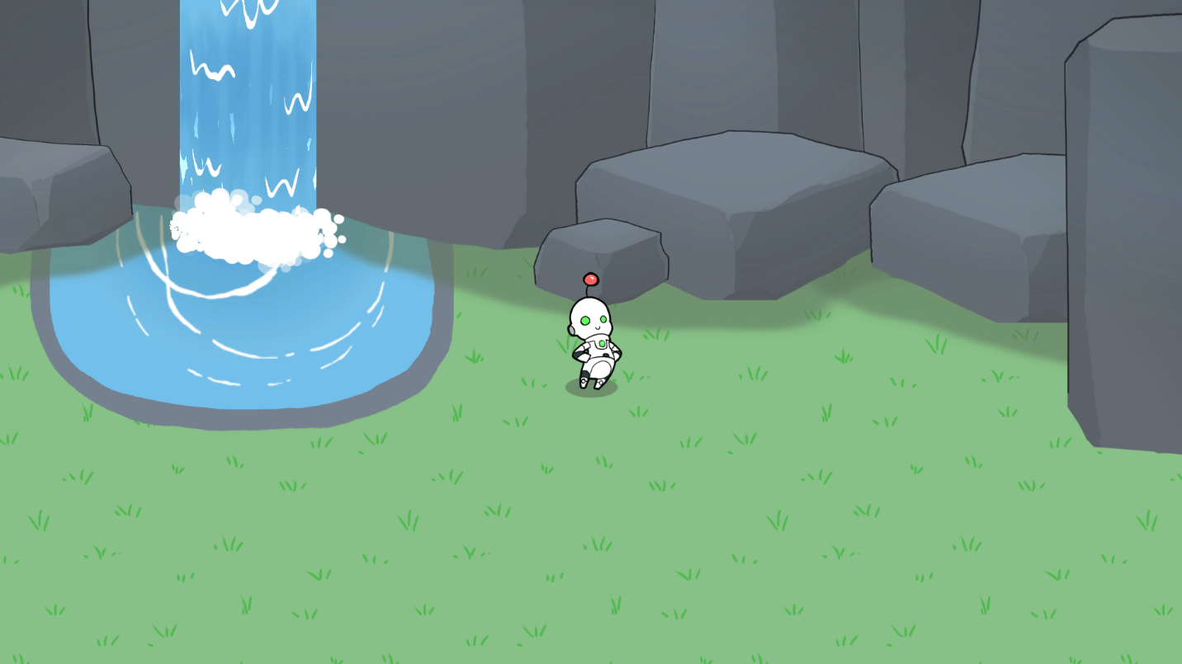
Mark step incomplete
2. Experience the 2D_Audio scene
Q&A (0)
In this step, you'll open the CreativeCore_2D project and then explore the 2D audio demo scene within it.
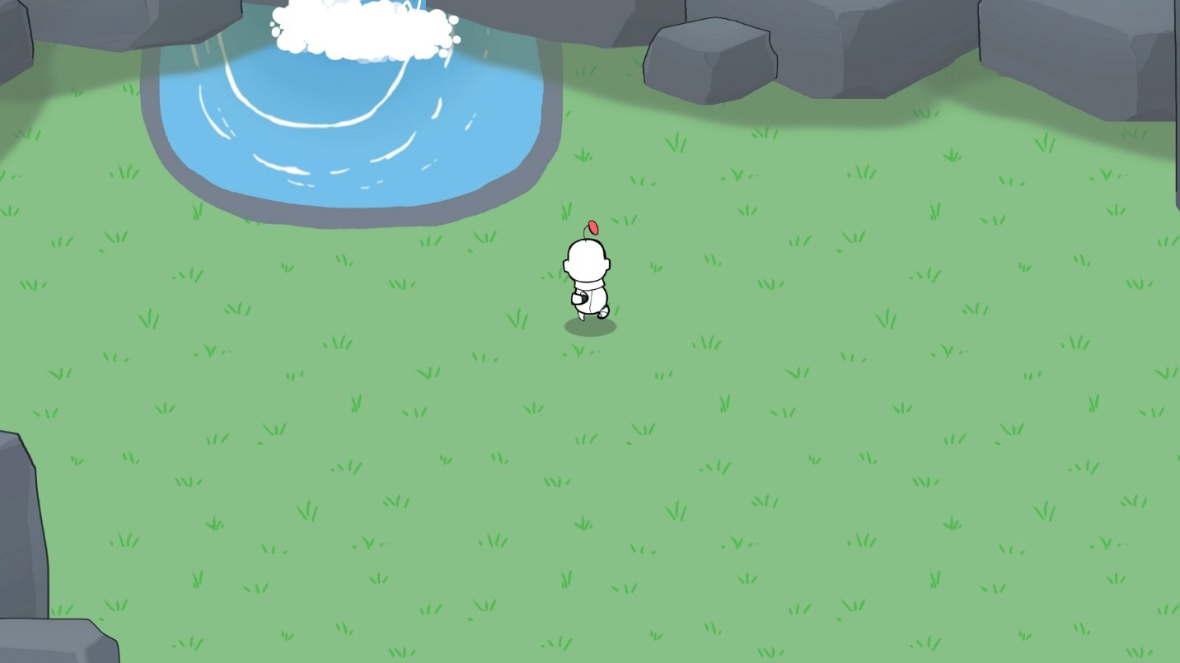
Play Video
Instructions
1. Download and open the CreativeCore_2D project:
- If you’ve already downloaded the CreativeCore_2D project in a previous unit, open it now using the Unity Hub.
- If you haven’t downloaded the CreativeCore_2D project yet, you can download the project here and then open it using the Unity Hub.
- When the project is open in the Unity Editor, verify you see a CreativeCore_2D folder within your Project window, containing several subfolders.
2. Open the CC_Audio_2D scene:
- Go to Assets > CreativeCore_2D > Scenes, then open CC_Audio_2D_Scene.
3. Enter Play mode and take note of the Audio elements:
- Enter Play mode.
- Notice the following:
  - The footstep sounds mimic those in the 3D scene, changing when the character goes into the water.
  - The waterfall sound grows louder as you get closer.
  - The reverb zone in the cave area makes the footsteps echo differently.
- Exit Play mode when you’re done.
Mark step incomplete
3. Explore the 2D vs 3D implementation
Q&A (0)
When implementing audio in Unity 2D projects, you'll find both similarities and key differences compared to 3D projects. For each of the similarities and differences listed below, explore the project to make sure you understand how each of the features were implemented in 2D.
What's the same?
3D spatial audio:
Unity's 3D audio describes how sound behaves in space, not whether your game is visually 2D or 3D. So just like you used 3D audio in your 3D project, you use 3D audio in 2D projects.
- Check the Audio_Waterfall GameObject's Audio Source component; its Spatial Blend property is still set to 3D.
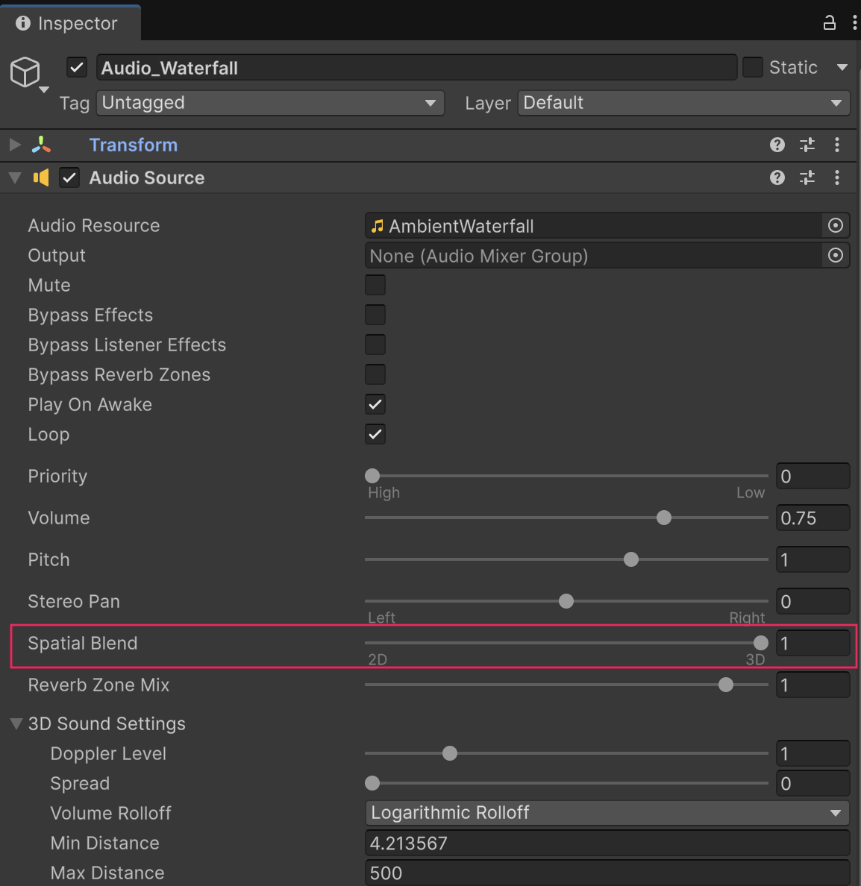
Reverb zones:
Environmental effects like reverb zones function the same way in 2D.
- Locate the Reverb Zone in the cave area; its setup mirrors a 3D implementation.
What's different?
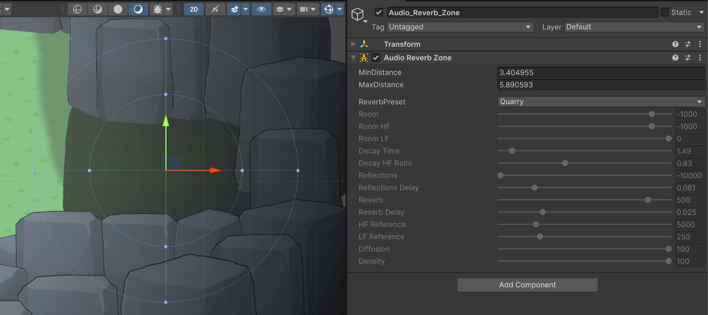
Footstep animation events:
While 2D animations can use events to trigger sounds just like in the 3D project, in this project they do so with spritesheet animations.
- In CreativeCore_2D > Animations > PlayerRobot > PlayerRobot_Anims, open one of the running animations in the Animation window.
- Expand the Sprite property to see the sprite images corresponding to keyframes.
- Select one of the Events along the top of the timeline and notice that PlayStep is listed as the Function.
- If you’re interested, open the FootstepManager script to see where the PlayStep function is written.
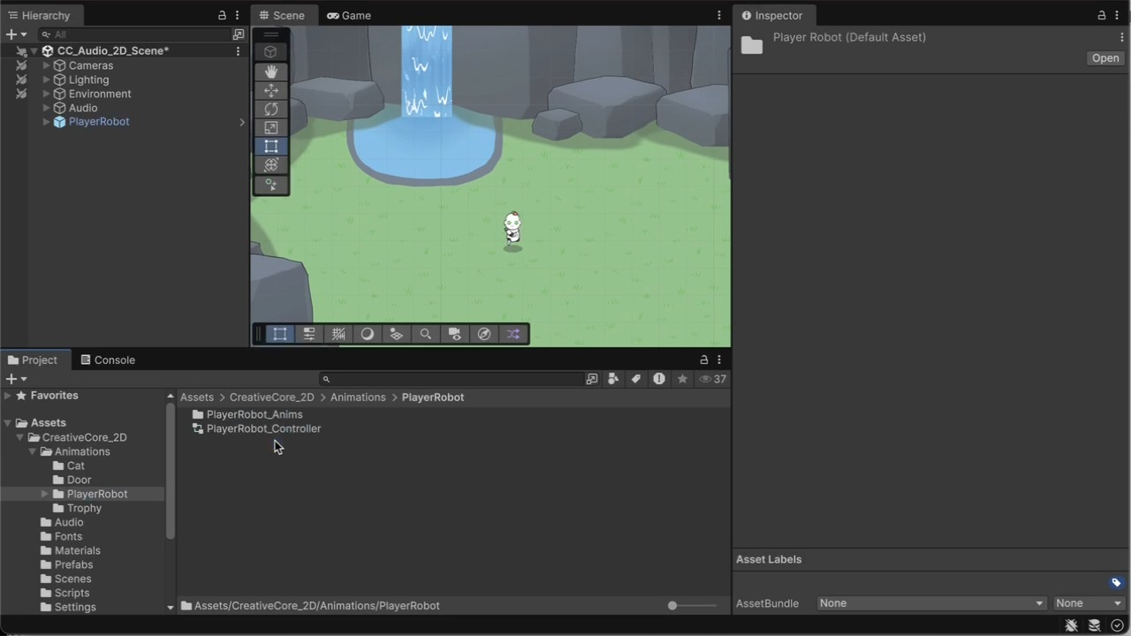
Play Video
Mark step incomplete
4. Next steps
Q&A (0)
You’ve successfully navigated the key similarities and differences in implementing audio for 3D and 2D Unity projects. You now understand how to create spatial audio, environmental effects, and animation events in both contexts.
With this knowledge, you’re ready to apply these concepts to your own personal projects, whether they’re in 3D or 2D.

